

Updating an EIB Template using the Submit Course Section EIB as an Example
DRAFT by Kristina Kelpe 7/8/2025
A Workday EIB (Enterprise Interface Builder) template can become out of date relatively quickly depending on several factors, but there's no strict expiration timeline.
General Guidelines for Updating an EIB
Time Since Last Update | Likelihood of EIB Failure | Notes
0-6 Months | Low | Generally stable unless BP or security changed.
6-12 Months | Moderate | One major Workday release could have introduced breaking changes.
12+ Months | High | Multiple releases may have deprecated fields or changed behaviors.

When an EIB template model is updated, it changes the defaults set up. This is critical in several Student EIBs where fields like Academic Unit often revert back to a default of “Academic Unit Hierarchy”. When you go to generate an EIB with data, having fields that aren’t used like Academic Unit Hierarchy are not helpful.

Updating an EIB Template Model
- Find your EIB Template
  - Go to View Integration System
  - Type in INTSYS: (and the your EIB name)
  - Go to a report of all your integration systems. This should contain the information about which version you’re on to help you see if you need to update.
- View your Template Model
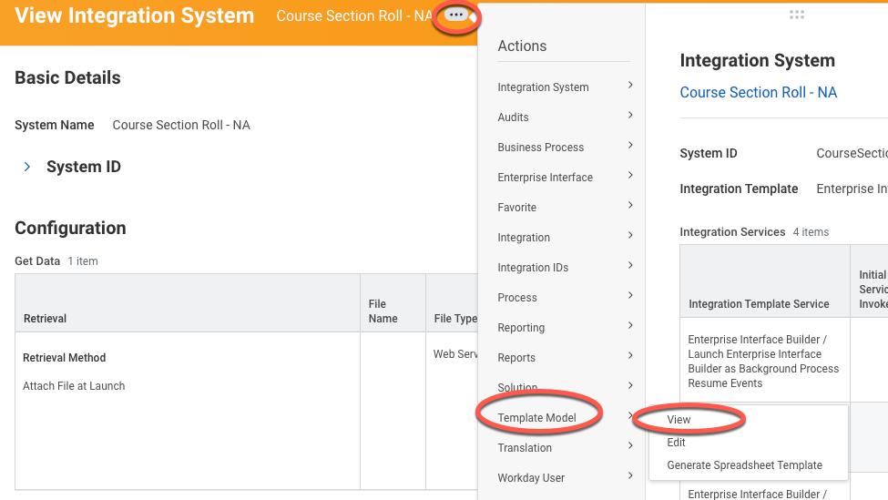
- Generate a new Default Template Model to update your version.
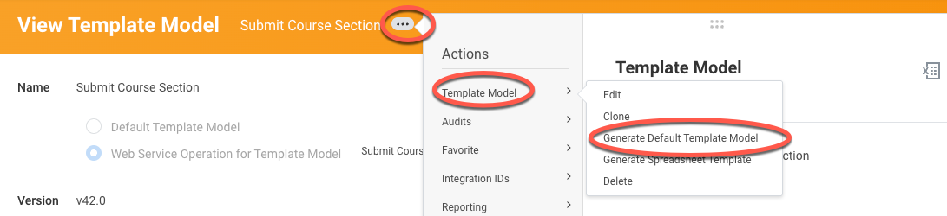
- It will list out the new version. Click OK.
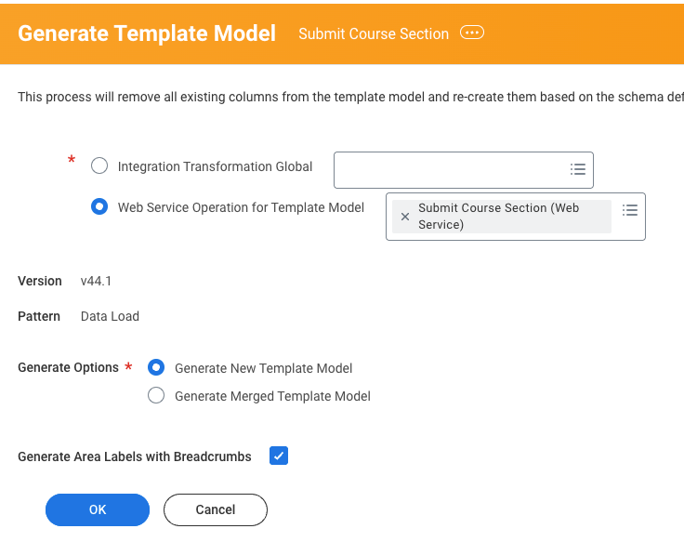
- Your version is now updated.

Update the Defaults in your Template (if needed – always needed for Submit Course Section EIB)
- From viewing your integration system, go in to View the template model.
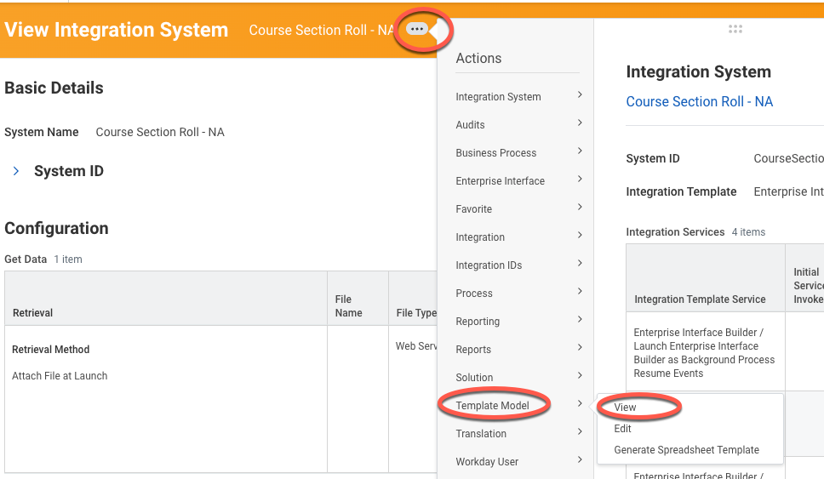
- Click on Edit Template Model Sheet
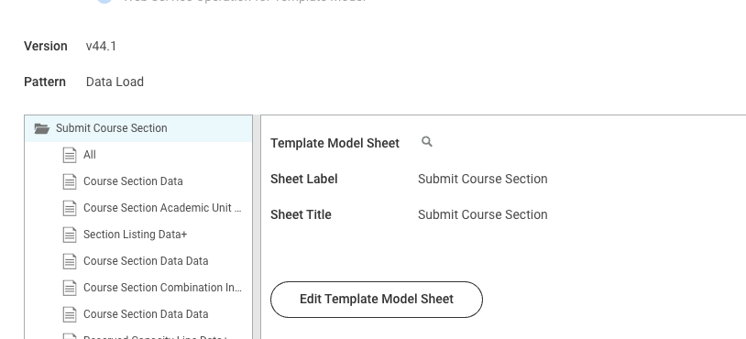
- Things to Update:
  - Label: Course Section Academic Unit Data +
Academic Unit – switch from Academic Unit Hierarchy to Academic Unit ID
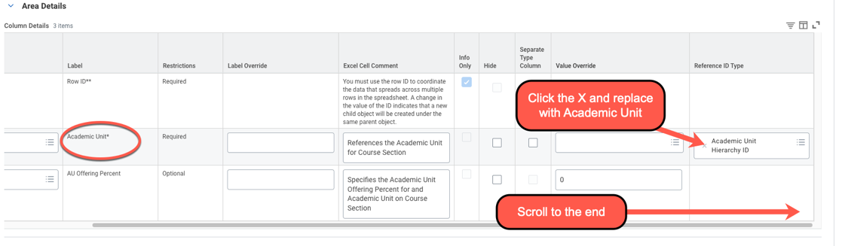
  - Label: Reserved Capacity Line Data +
Reserved Capacity Line Eligibility Rule – switch from Application Additional Education Interest Eligibility Rule ID to Eligibility_Rule_ID
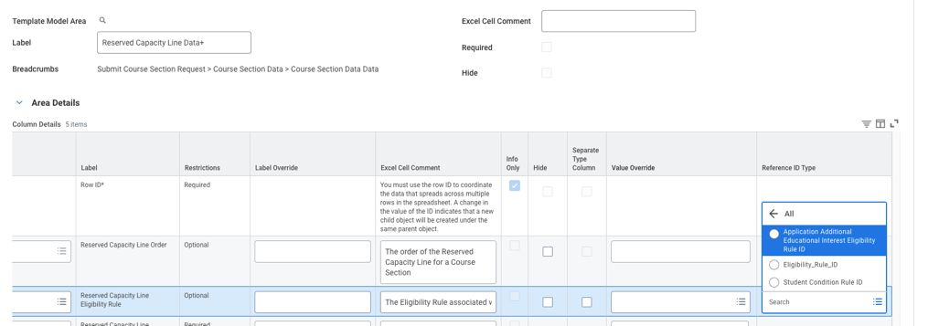
  - Label: Instructor Role Assignment Data +
If you want to change instructors, you may want to switch off of Academic Affiliate ID to Employee ID
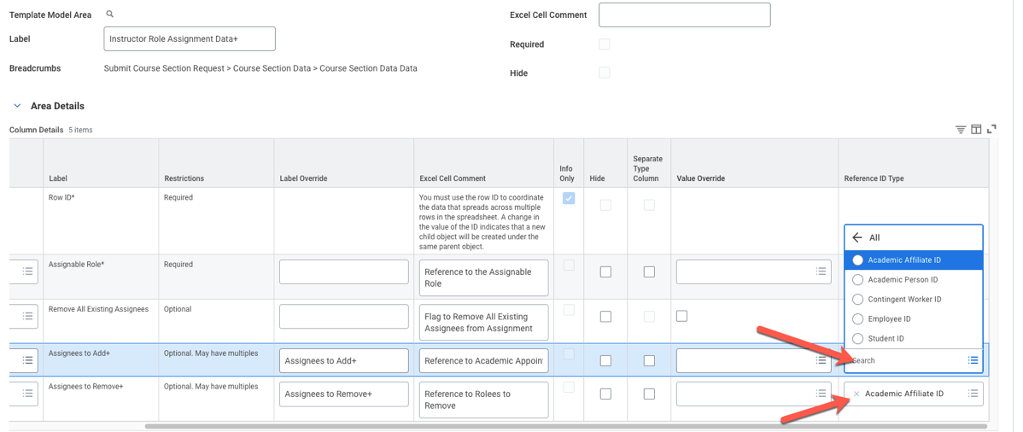
  - Label: Course Section Data Data
Student Eligibility Rule – switch from Application Additional Education Interest Eligibility Rule ID
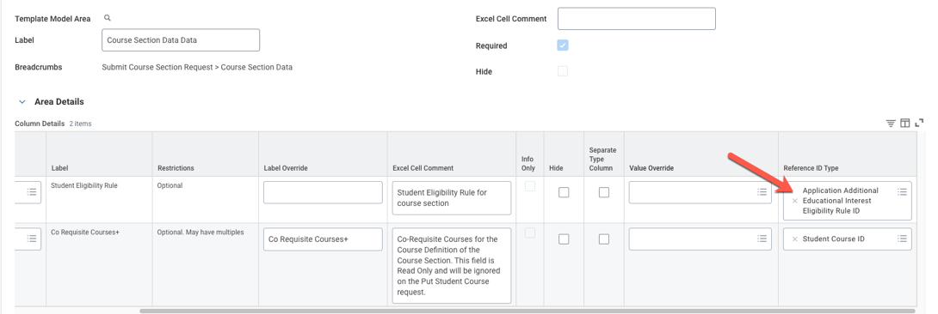
- Click OK.
- Change your defaults to generate with data.
- Generate your template. These defaults will now appear at the top instead of what Workday defaults.

